# Steps performed to complete the project:

Step1: Data connection & blending between primary & secondary dataset.

Step2: Created calculated field & parameters for four sheets like Map, KPI, Growth Indicator & Trend Line

Step3: Created dashboard & populated it with the above four worksheets, then activated them via “Dashboard actions” so they coordinate with eachother & display results from various worksheets.

I will copy paste my four pages for reference and how the sheet look like, by end dashboard URL will be input from my tableau.

Details of the project:

1. Data connection & blending:

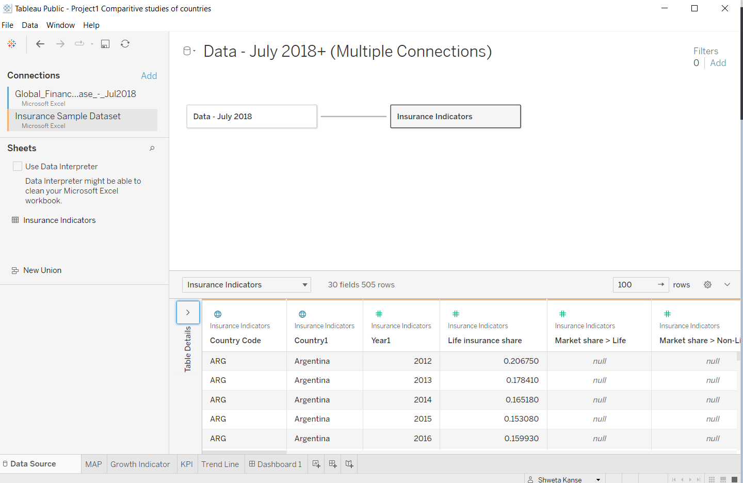

1. Created calculated field & parameter:
2. Select Category: click on “Create Parameter”, then input below details which are present in primary dataset.

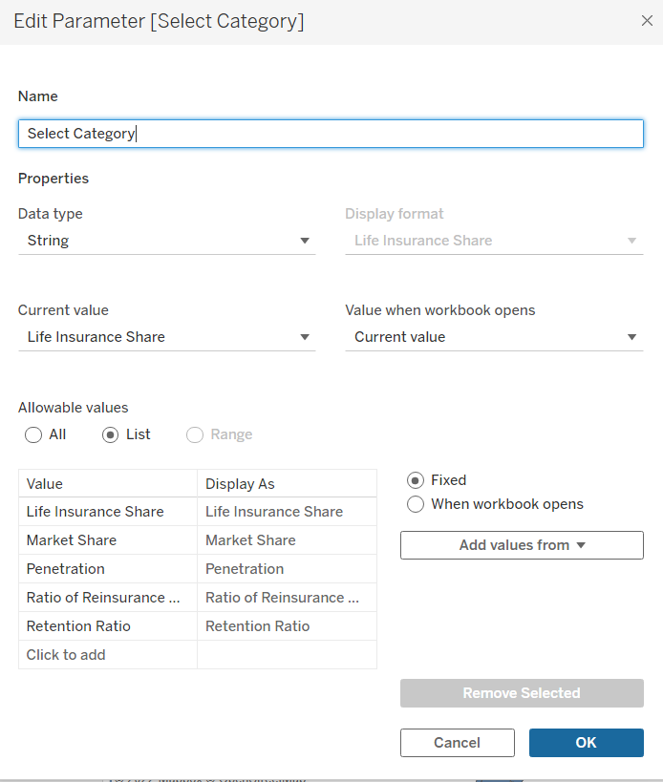

1. Create Year: Create on parameter & input below details to create year parameter

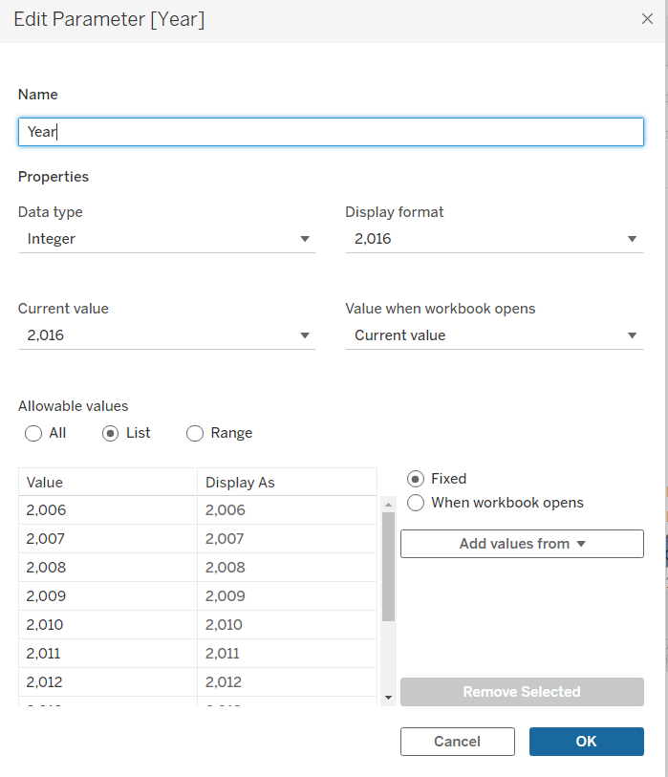

1. Create “Select Category” by using calculated field: click on calculated field by analysis pane and input below code to get “select category” field:

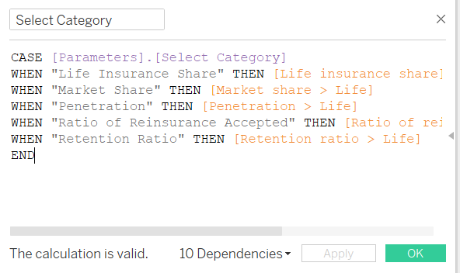

1. Create selected period value (CY) by performing same step but different codes:

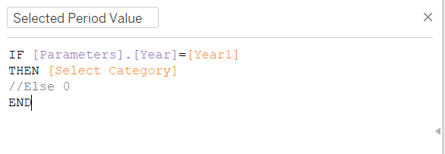

1. Create comparison period value (PY):

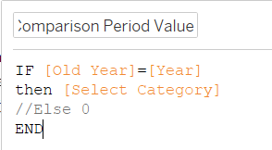

1. Create Old Year field:

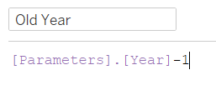

1. Create Growth% by using below code:

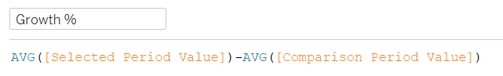

1. Create Growth Color:

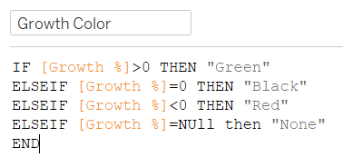

1. Create Growth Indicator:

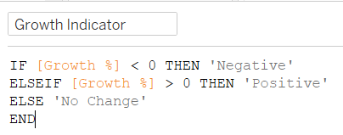

1. Screenshot of four sheets:
2. MAP:

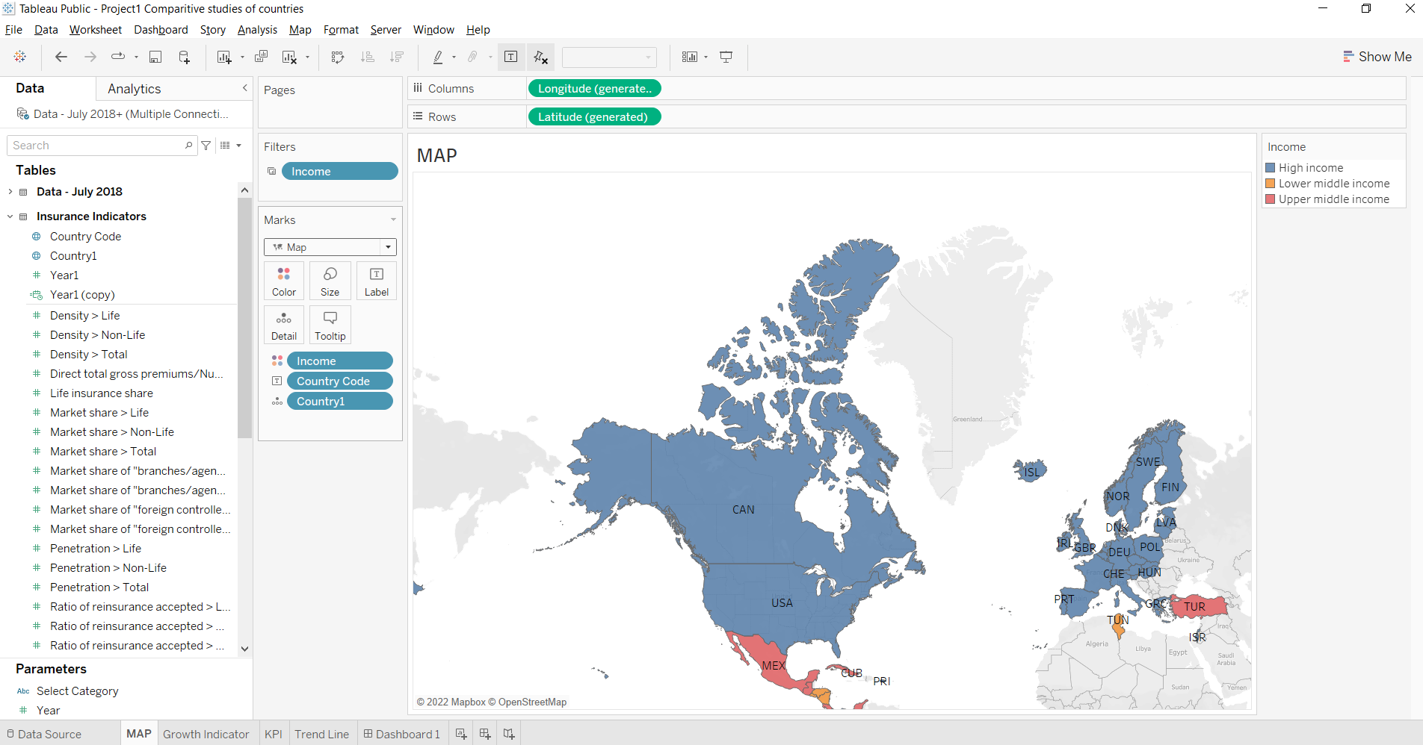

1. KPI:

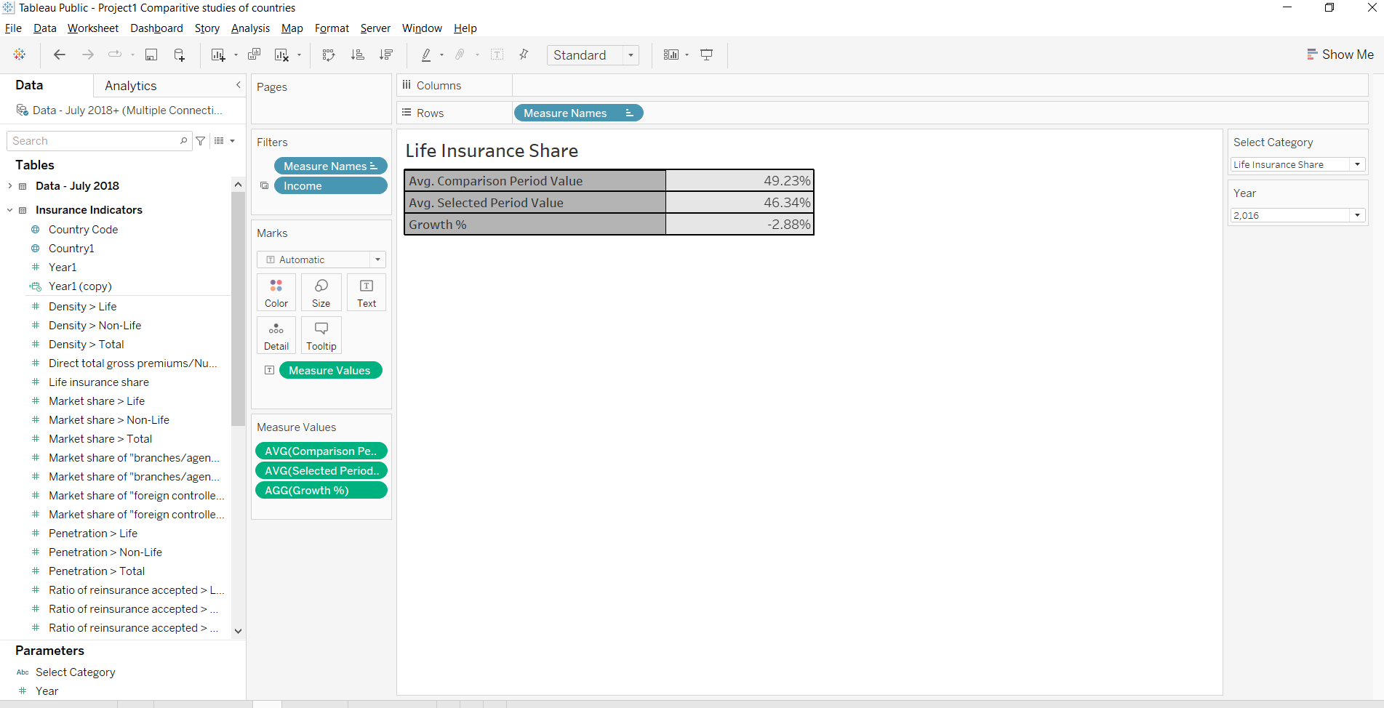

1. Growth Indicator:

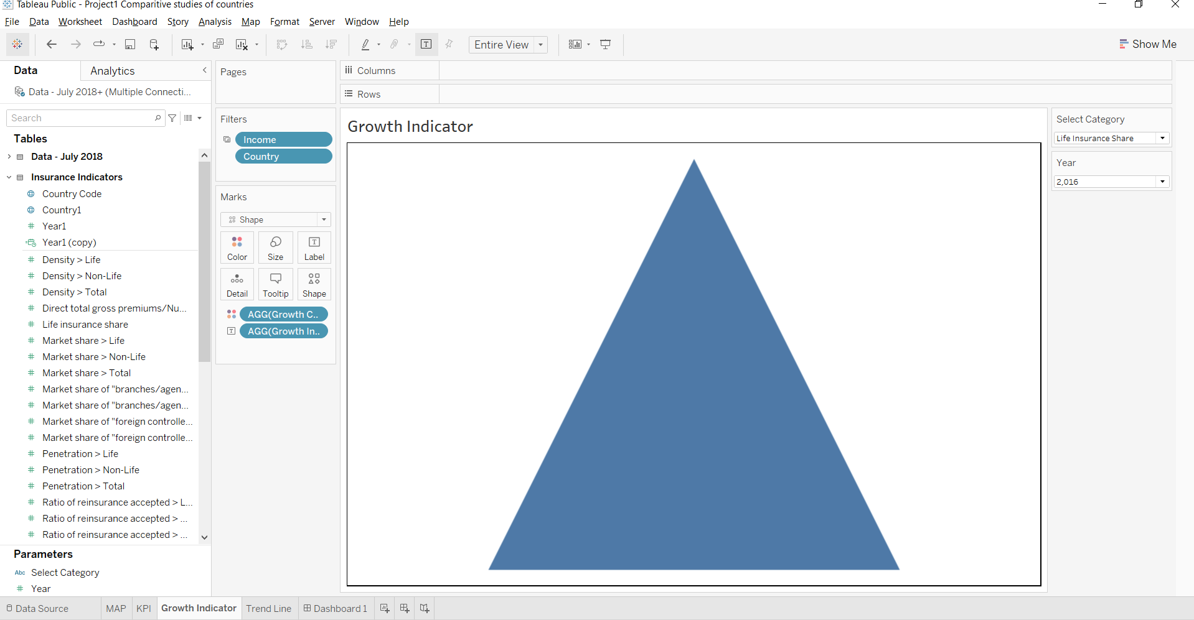

1. Trend Line:

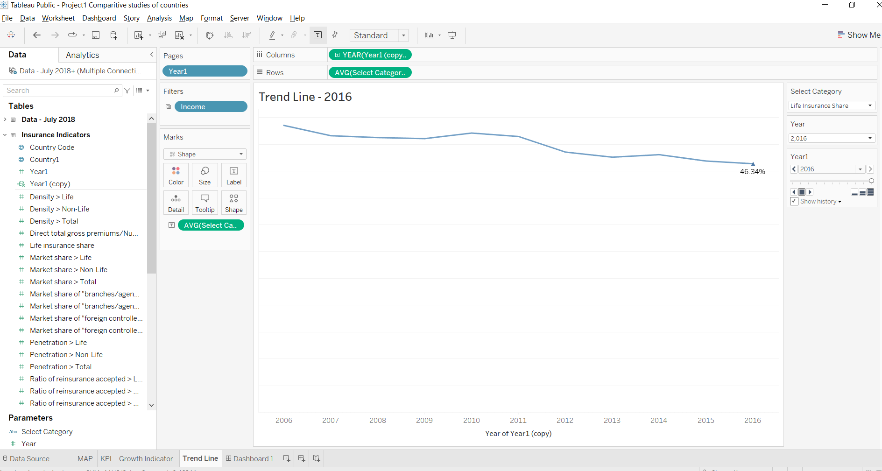

1. Dashboard: Final dashboard screenshot

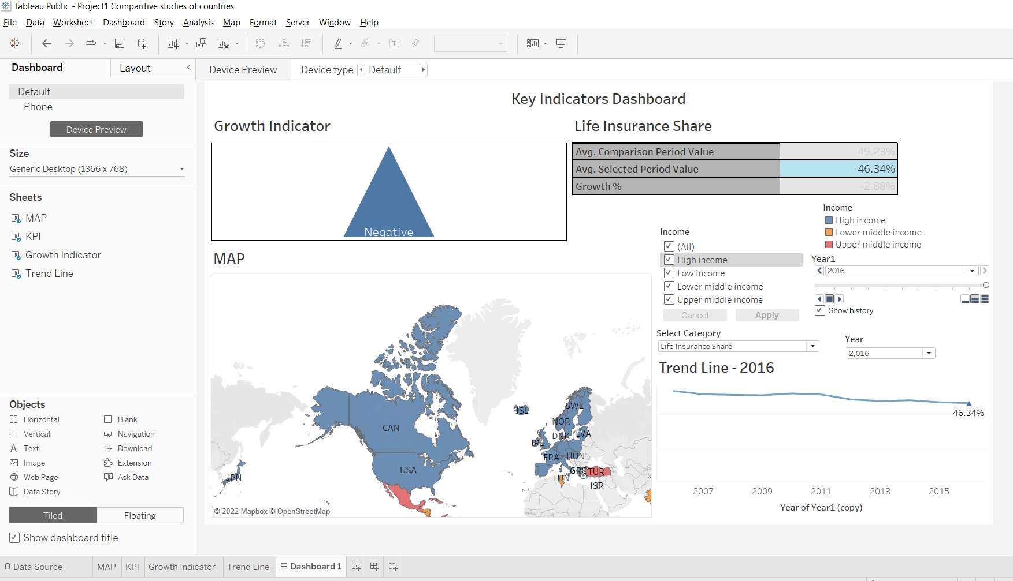

Entire dashboard is prepared on based of my understanding of the project, I’m trying to show to my client from my dashboard that which country can give maximum or minimum business based on the trend line. The income matters allot here for business growth.